**User Input**

**Length of String:  
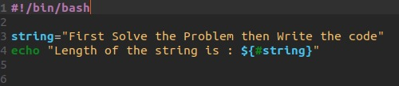**

**If Else:**

**Switch Case:  
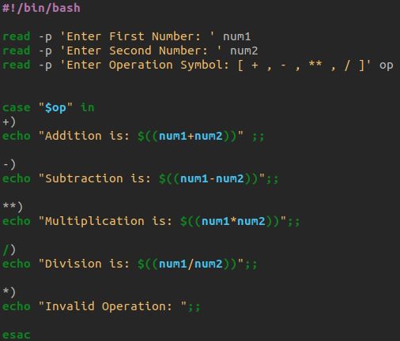**

**FOR LOOP:**

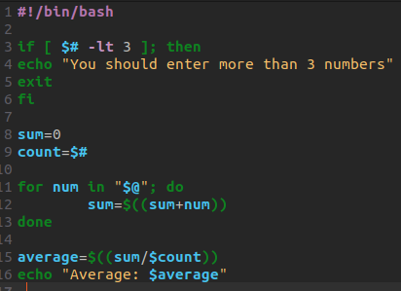

**DO WHILE LOOP:  
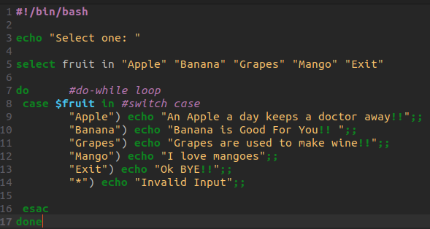**

**DETECT Prime Number Using FOR LOOP:  
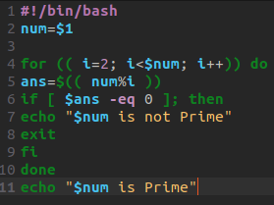**

**CREATING AND EDITING FILE USING SHELL:  
